R. D. SHELLEY
MARINE SURVEYOR
POST OFFICE BOX 7643, SAINT PETERSBURG, FL 33734
(727) 480-3172
Email: RDShelley@hotmail.com
________________________________________________________________
Survey File #034455A20CV Date: April 10, 2020

REPORT OF SURVEY OF Split Decision

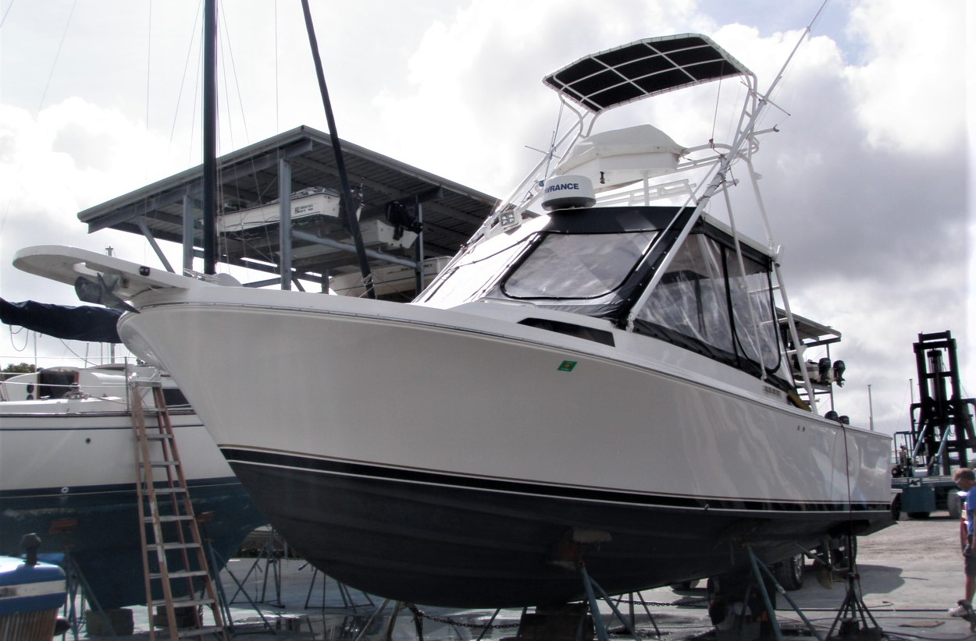

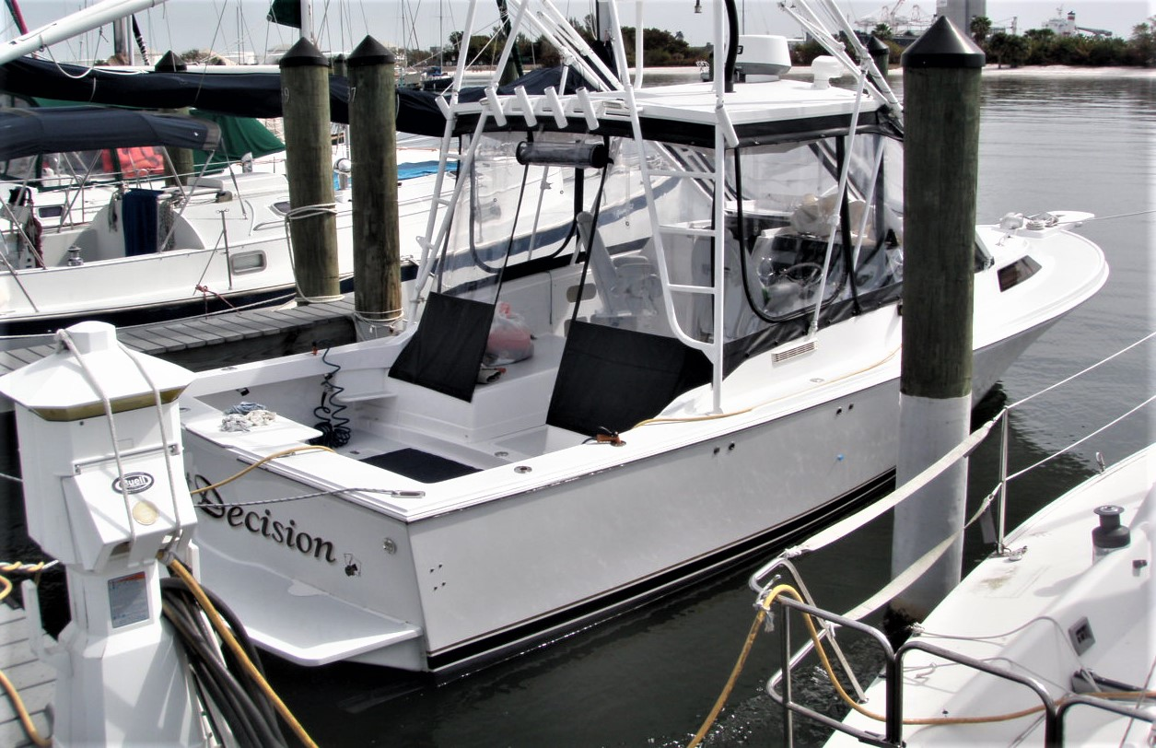
SURVEY REQUESTED BY: Mike Gable

VESSEL OWNED BY: Michael T. Gable
1008 Lenna Ave
Seffner, FL 33584

This is to certify that at the request of Mike Gable, the attending surveyor did, on February 12, 2020, attend the survey of the vessel described below where she lay hauled out of the water at Shell Point Marina in Ruskin, Florida. An inspection afloat, in the water at the docks of the Davis Island Yacht Club and a trial run in the waters of Tampa bay occurred on March, 3rd. 2020.

Information regarding the inspection is contained within the body of the report. The purpose of this inspection was to determine the general condition and estimated present day market value of this vessel. Abbreviations are used in this report to identify marine related agencies and organizations that have established standards that should or must be followed. These are: United States Coast Guard (USCG), the American Boat and Yacht Council (ABYC), and the National Fire Protection Association (NFPA).

The following is a report of the examination and findings.

GENERAL INFORMATION

TYPE VESSEL: Custom Blackfin 29 Combi Express
BUILDER: Blackfin Yacht Corp., Williston, FL Rebuilt Gable Enterprises completed 4/2018
YEAR: 1989 model year with custom re-fabrication in 2018
HULL IDENTIFICATION NUMBER: KMA29173A989
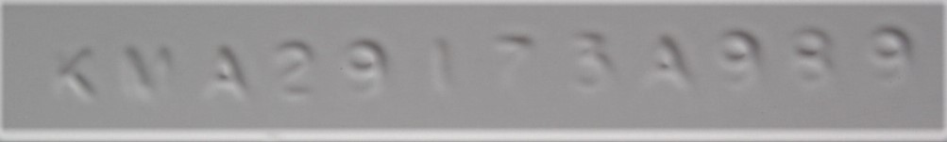
TITLE NUMBER: 110640723
STATE REGISTRATION NUMBER: FL 1035 PL
LOA: (with pulpit) 32’6” LOD: 29'4" BEAM: 10'6" DRAFT: 2'10"
DESIGNED DISPLACEMENT: 12,120 lbs.
ACTUAL DISPLACEMENT 10,000 lbs.
CONSTRUCTION

HULL Molded solid laminate of fiberglass reinforced plastic (FRP) further reinforced with stringers, bulkheads, FRP interior components and other transverse and longitudinal members bonded to the hull. FRP cored/vacuum bagged swim platform, transom mount rudders, custom non-corrosive FRP Gable Enterprises trim tabs mounted with noncorrosive Kevlar/carbon hinges. Twin Lumitec bi-color Underwater lights. Hull topside finish is painted Awlgrip snow white.

DECK Molded, cored FRP laminate incorporating the foredeck, side decks, house, superstructure cockpit, bridge-deck and bulwarks in one contiguous structure. Hull to deck joint thru-bolted and sealed with 5200 finished with new Taco V21 white rubrail. Deck finish is painted Awlgrip Chevy white with grit texture non-skid panels.

INTERIOR Wood, Poplite plywood and FRP components. Interior finish has vanished hardwood, cork covered counter tops, 12v LED interior white/red light fixtures, EVA foam floor covering with hinged access step and bilge access. Waterproof white-cloth folding shower door. Headliner removed and fiberglass overhead painted with off white flat finish.

STEERING Hynautic hydraulic system has a stainless-steel wheel with suicide knob starboard forward in cockpit driving a single hydraulic ram attached to a tiller arm on the starboard rudder stock with a tie bar that cross connects it to a tiller arm on the port rudder stock. Bronze rudders with stainless steel shafts. Non-corrosive FRP laminate and epoxy foil faired encasements.

TRIM TABS Bennett hydraulic system with FRP non-corrosive custom trim tabs built by Gable Enterprises and custom Kevlar non-corrosive hinges.

DECK LAYOUT Bridge deck forward has helm station to starboard with engine instruments and controls, electrical switches, electronics, trim tabs controls, compass and Pompanette custom pedestal helm chair, companionway and Pompanette custom pedestal passenger chair forward to port; engines boxes outboard port and starboard with bilge/engine room access hatched between. Zippered fast access safety gear/life-vest storage above head, Full canvas and Strataglas vinyl enclosure curtains with U-zip windows. White/red LED light fixtures,

Cockpit aft has gunwale mount rod holders outboard, custom built-in transom livewell central aft with viewing window and a King Starboard plastic bait-station/fish cutting lid, FRP custom cored aft deck and sole hatches, split salt/freshwater washdown water spigots, shore power receptacle, under-gunwale cockpit blue LED light fixtures, two 50 amp electric real female plugs
Tower hinges above hardtop for height clearance and has LED spreader lights, rocket launcher rod holders aft, Helm station with stainless steel wheel with a suicide knob, tachometer, engine controls, windlass controls, storage and a buggy top. Tower finish is painted Awlgrip white.

DECK HARDWARE Molded FRP anchor platform with a Maxwell anchor roller assembly, custom Bomar trapezoidal deck hatch, smoked bronze acrylic plastic house windows, stainless steel hand grabs, RCL remote 12-volt spotlight, Rupp outriggers, fenders, chocks, cleats lines, deck plates and sundry other deck gear.
ENGINES PORT STARBOARD

MAKE AND MODEL Twin Volvo model AD41P-A, six-cylinder marine diesel engines each developing a reported 200 horsepower.

REPORTED HISTORY Both engines reported new 1995 with starboard side rebuilt 12/2017 and the port side rebuilt 03/2019

SERIAL NUMBERS 2204153447 2204149829

RECORDED HOURS Digital hour meters inoperative at inspection

FUEL LINES Primarily USCG type A1 neoprene hose with in line priming bubs and Racor filters

LINKAGES Morse type with dual lever controls

EXHAUST Wet system. discharge fittings at the transom have rubber anti backflow flaps installed.

MOUNTING Isolation mounts bolted to laminated stringers.

VENTILATION Natural and 12-volt blower negative flow forced ventilation.

GEARBOXES Volvo Penta model MS4A, 1.93:1 ratio marine reduction gears. Owner reports 1 new, 1 rebuilt
SERIAL NUMBERS 3101054500 3101011351

GAUGES Twin analog tachometers with (inoperative) digital hour meters, oil pressure, water temperature, gear oil temperature, exhaust gas temperature, boot pressure and volt meters. Single fuel gauge.

SHAFTS Aquamet 22 1 3/8” stepped down to 31 mm with new couplers and running gear

PROPELLERS Pair of new, counter rotating 18 X 22 four blade Michigan DQX nibral with #5 cup.

STRUTS Custom non corrosive foil shaped Carbon/Kevlar shaft struts glassed with structural knees to inner hull side laminate.

FUEL TANK One tank of welded aluminum construction located on centerline aft of the engine space with a reported capacity of 200 gallons. Tank had been removed, covered with an FRP skin and painted in 2018. Visual gauge on tank top. Tank has an inspection port and a bonding wire.

FRESH WATER One tank of aluminum construction to port in the engine space with a reported capacity of 25 gallons.
Gauge alongside the main electrical panel.

PUMPS Shurflo 12 volt fresh water pump
Bait Sentry 800 12 volt live well pump
12-volt Saltwater washdown pump

PLUMBING Primarily plastic tubing. System has control valves for salt/fresh use.

THROUGH HULL Ball valves with custom machined low profile through
FITTINGS BELOW hull fitting for high speed performance on most
WATERLINE Holding tank discharge: Aft and outboard of port engine
Air conditioning intake: To port of centerline in lazarette.
Engine intakes: Two seacocks located central aft in engine space
Head intake: To port of centerline inboard of the port engine.
Deck wash/salt water and live well pump intake: to port of transom bilge pump.
Transducers: Two transom mounted and one forward in lazarette
Shaft logs: PYI dripless shaft seals with rubber billows and clamp attachments to shaft log tubes aft in the engine room.
Rudder ports: Transom mounted
Underwater Lights: (2) Lumitec bicolor bonded and 12v

ELECTRICAL SYSTEM

TYPE 12-volt d/c and 110-volt a/c systems.

12 VOLT Four group 31 maintenance free 12-volt batteries with two wired in parallel for the house service and two for engine starting All batteries mounted in a custom FRP box integrated as seat for engine maintenance with locking hasp lid.

110 VOLT 30-amp shore service with marine type shore cord.
Xantrex Freedom 1800 inverter/40-amp charger

PANELS Circuit breaker panel with analog a/c and d/c volt meters and ammeters. Maxwell windlass circuit breaker panel,

BATTERY CHARGER Xantrex Freedom 1800 inverter/40-amp charger
Blue Sea SI-ACR, automatic charging relay

BONDING Connections made from all aluminum tanks, thru hulls to sacrificial zincs mounted on stern,

ELECTRONICS AND NAVIGATION AIDS

COMPASS 3" illuminated Ritchie (X2)

VHF Raytheon Ray 45
Icom IC-M45

CHART PLOTTER Lowrance HDS7 gen 2 chartplotter with side-scan networked
WITH DEPTH Lowrance HDS8 gen 2 chartplotter with side-scan networked
AND RADAR Lowrance 3G Radar and Dome
Lowrance Satellite XM Weather and Antenna

AUTOPILOT Simrad AP11

ENTERTAINMENT Dual 12 volt am/fm/cd XM stereo with remote control, Two pairs of speakers (interior / exterior)

INTERIOR Cabin features a V-berth central forward with storage below and on hull sides.
Galley to port has lockers, Galanz microwave oven, Mr. Induction single burner stove and a Haier refrigerator with freezer. Companionway aft to cockpit w custom FRP pocket doors and folding cored removable FRP hatch.
Enclosed head compartment aft to starboard has a countertop washbasin/ pullout shower head and an electric macerating marine toilet discharging to a plastic holding tank located in the engine room. Tank is evacuated overboard with a separate pump or shore side by means of a dockside waste deck pump out fitting. Shower drain sump with Rule 800 g.p.h. pump with float switch.

AIR CONDITIONING Custom Pompanette 6,000 BTU 12-volt, marine system installed. A/C thermostat/temp gauge in galley
SAFETY EQUIPMENT: REQUIRED

FIRE EXTINGUISHERS: See recommendations, aboard are:
mfg. date & type size tag gauge mounted
2002 dry chemical BC-I -0- green cabin
2016 dry chemical BC-I -0- green cockpit

LIFE RINGS Compliant

USCG APPROVED Several type II adult
PFD's

NAVIGATION Compliant
LIGHTS

VISUAL DISTRESS Not observed
# Type USCG approval # Expire date
- 12-gauge signal launcher
4 12-gauge meteor cartridges 160.066/34/0
4 Red hand flares 160.021/18/0

SOUND DEVICE No specific equipment requirements on this size vessel.

SAFETY EQUIPMENT: OPTIONAL

BILGE PUMPS Rule 500 g.p.h. fully automatic 12-volt submersible in the bilge area in the accommodations area.
Rulemate 750 g.p.h. with float switch in the bilge area aft in the lazarette.
Rule 1500 g.p.m. 12-volt submersible in main engine bilge

OTHER Two Xintex Carbon monoxide detectors
High Water Alarm in tandem with mid bilge switch

GROUND TACKLE Delta modified plow type with 20’ chain leader and 350’ nylon rode.
Maxwell 12-volt windlass with two helm remote controls
8 lb. Fortress aluminum stern anchor with Nylon rode.
RECOMMENDATIONS

- Attend to the following for USCG and or NFPA compliance:
- Ensure that current visual distress signals for intended day / night use are aboard.
- Ensure that the required MARPOL garbage disposal placard, oil spill placard and waste management plan are properly posted aboard.
- Display the FL registration numbers.

SUGGESTIONS The following suggestions are offered to enhance safety, value and utility. However, as opposed to recommendations, suggestions do not require immediate attention for compliance with regulations or to prevent sea water intrusion.

SUMMARY AND VALUATION

Blackfin Boats was founded by Carl Herndon in 1973 in Williston, Florida. The company has had several owners over the years but is still producing quality fishing boats in 2020.

The Blackfin 29, a popular model built in fiberglass from production molds was introduced in 1983 and remained in production through 1998. It was also built in a limited production run by Salt Shaker Marine from 2001 through 2003. The Blackfin 29 was described as “hands down the most expensive sportfisher around” in an article in Sea Magazine back in 1997. Carl Herndon who had worked at Bertram Yachts saw both Bertram and Hatteras, the two leaders in saltwater sport fishing boats abandoning the smaller end of the market to build larger boats. He came in to fill the void by founding Blackfin and producing high quality sport fishing boats in twenty foot plus and thirty foot plus size ranges. The Blackfin 29 was successful in taking over from the iconic Bertram 31 as is evidenced by the success and longevity of this model. Even David Pascoe, noted marine surveyor, author and boat reviewing curmudgeon gave the Blackfin 29 his highest marks.

Split Decision is an example of this Blackfin 29 that is owned by, has been re-manufactured by and has been upgraded by Mike Gable, owner and operator of Gable Enterprises, one of the premier custom fiberglass fabricating, repair and manufacturing operations in the Tampa Bay area. Mr. Gable and Gable Enterprises have been involved in boat design, construction and repair since 1980 with an overabundance of notable projects on their list of accomplishments and an enviable list of clients. A check of the Gable Enterprises website shows projects that range from resin infused skateboards to world class racing sailboats. Mr. Gable has a high degree of expertise in state-of-the-art composites including carbon fiber, Kevlar, S-glass, E-glass, vacuum bagging, resin infusion and has employed these methods, materials, techniques and skills in both construction and repair. This is mentioned in this report to help explain why a 1989 Blackfin could and would have such a high level of custom and costly modifications. As his personal boat it has been done to an extreme for his own benefit and as an example of his capabilities to maintain and bolster his reputation in the marine community. He has also used his connections in the marine industry to obtain custom parts and equipment used during the modification and outfitting process. Mr. Gable reports over $162,000.00 in expenditures for material and subcontract labor were spent on this project as of May 2019 and with his own labor factored in at a modest $40.00 per hour the total project cost would go to $310,000.00.

The subject vessel was stripped to the bare bones, re-manufactured and upgraded to contemporary standards. The targeted elimination of weight was achieved through numerous major modifications including re-engineering the interior layout, replacing all interior plywood with weight saving Poplite, remanufacturing the entire cockpit sole with a removable component weighing in at only 73 lbs. and remanufacturing the swim platform with a new component weighing 47 lbs. Further modifications were done to reduce drag through the water including stepped down shafts, redesigned and custom fabricated shaft struts, covers on the prop shaft exit slots, custom machined through hull fittings and a bottom finish that is smoother than most other hull topsides. These enhancements resulted in the intended positive effect on both fuel economy and increased range allowing Split Decision to cruise through the length of the Bahamian chain without having to carry an extra drum of fuel on deck. Additional upgrades to this respected design were made to bring the interior layout, the systems and the components to today’s standards. The overall condition at the time of this inspection was, in the opinion of the undersigned, nearly new.

During this general survey, the engines fired readily from a cold start condition with no appreciable smoke in the initial exhaust gasses. During the trial run the engines were operated at various throttle settings including wide open throttle (WOT). Speeds of 10.2 knots at 2,000 r.p.m., 16.3 to 16.7 knots at 2,500 r.p.m., 21.1 knots at 3,000 r.p.m., 23.9 to 24.8 knots at 3,300 r.p.m., and a maximum 28.4 knots with the engines operating at WOT of between 3700 and 3800 r.p.m. with all information per the onboard analog tachometers and Lowrance chart plotter. Other onboard analog engine instrumentation showed voltage at 14V, coolant temperatures in the 175-degree range, transmission temperatures in the 130-degree range and oil pressure in the 60+ p.s.i. range. This cold start and trial run provided an overview of the engines and their performance for this general survey. A mechanical survey by a qualified marine mechanic would be required to learn specifics about the condition and projected longevity of the engines, drive trains and associated equipment. Both the autopilot and the trim tabs responded to control commands.

Inspection of the hull with the vessel hauled out of the water and blocked ashore showed fresh antifouling paint had been applied over an exceptionally smooth, and fair surface. Both topsides and bottom presented as a new boat. The topsides had been modified, filled, faired primed and painted. The bottom had also been. Antifouling paint was spray applied and then wet sanded to a 600-grit finish. No concerns with the hull laminate were observed or detected through random soundings of the bottom. The new propellers were free of any corrosion or impact damage. The custom carbon fiber shaft struts were also without damage or issue. The cutlass bearings were new. The rudder stocks had no play in their ports.

The seacocks listed earlier in this report were proved to be hand operational. The electric bilge pumps were confirmed to run.

FRP bondings between hull and support members were found to be intact where available for inspection.

The basic operation of each of the marine electronic systems was confirmed. The full range of functions and accuracy of each of these systems was not verified as part of this inspection.

The basic operation of other systems and equipment aboard including the domestic galley appliances, pressure water system, toilet, steering system, air conditioner, inverter etc. was tested and found operational at inspection or was listed for repair.

Fuel, water and holding tanks were viewed where accessible without filling to maximum capacities. No conditions of concern were observed however, portions of all of this vessel's tanks are sufficiently hidden from view that no opinion as to the viability of these tanks is offered herein. In order to prove the integrity of any of this vessel's tanks, pressure testing in accordance with ABYC standards would be required.

Some information in this report including but not limited to the vessel’s dimensions and tank capacities was obtained from sources believed to be reliable and was not verified as part of this inspection.

Other survey and diagnostic services are available and should be requested if further information is required.

Obviously, with hundreds of thousands of dollars spent in a remanufacturing process, published book values would not be applicable to help establish an estimated fair market value. To try and arrive at a realistic, estimated fair market value using market comparatives takes a bit of extrapolation. Asking prices for production examples of the Blackfin 29 Combi currently on the market were: $45,000. for a 1992 example in Mexico, $27,000. for a 1989 gas powered example In Winthrop, MA, $64,995. for a 1996 example in Mechanicsville, VA, and $85,000. for a 1984 example in Stevensville, MD. Selling prices for examples of production Blackfin 29 Combi reported to Soldboats.com from 2018 to present range from $4,500. for a 1985 powered with twin GM 8.2, 240 hp diesels in NJ to $74,500. for a 1996 powered with twin Cummins 370 hp diesels.

The asking prices of other similar re-manufactured vessels include: a 1970 Bertram 31 custom remanufactured by Elite marine in 2015 has an asking price of $119,900. Thirty-two other Bertram 31’s currently offered for sale on Yachtworld show seven priced between $100,000. and $200,000. one at $225,000. one at $375,000. and one at $395,000. Others make and model examples include a 1973 Uniflight Sport Sedan custom remanufactured between 2012 and 2016 asking $110,000. a 1985 Blackfin 32 Convertible remanufactured between 2016 and 2019 asking $129,000. a 1977 Topaz 27 upgraded in 2013 asking $249,500.

ESTIMATED FAIR MARKET VALUE $125,600.00
ESTIMATED REPLACEMENT VALUE $248,000.00

The survey of this vessel is based solely on a careful visual and nondestructive inspection of accessible portions of the vessel structure and available equipment.

No responsibility is assumed for defects in the hull, any machinery, or any equipment latent or otherwise. Attending surveyor, representatives or agents are not to be held responsible for any error of judgment, default, negligent omission, misrepresentation or misstatement in any report. This survey is not an inventory or listing for sale and should not be construed as such. This survey is not a certificate of seaworthiness and should not be construed as such. No guarantee or warranty is expressed or implied.

Respectfully submitted by

Rick Shelley, A.M.S.
Accredited Marine Surveyor
Member: S.A.M.S.

